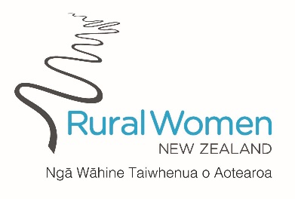

RWNZ National Service Award:

Nominations can be made to the RWNZ Board by any Branch, Provincial or other Group; the Board shall decide the Awards to be given. The National Service Award is conferred on a Member nominated by a Group in recognition of committed service shown to the organisation.

The nominating Group must complete the RWNZ Nomination Form and provide all the requirements of the form before it goes to the Board for decision.

The form must be completed and all supporting documents must reach National Office by Friday, 6 October 2023

Post to:
Rural Women New Zealand
PO Box 12-021
Thorndon
WELLINGTON 6144
Email: competitions@ruralwomennz.nz

